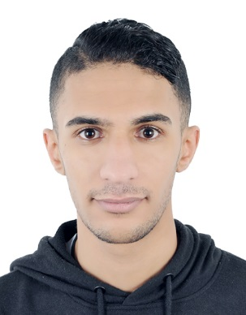 **Curriculum Vitae**

**MAHMOOD ALI SALMAN NASER   
Mobile No.: 00973-32219129  
Email Add: mahmood_1998@hotmail.com  
  
 CAREER OBJECTIVES**

To achieve success in my career with leading organization which will enable to utilize my talent, skills and achieve my aspiration.

**PERSONAL INFORMATION**Date of Birth : 09/11/1998   
Nationality : Bahraini  
Gender : Male  
Marital Status : Single  
CPR No. : 981102530  
Languages known : Arabic and English

**EDUCATIONAL QUALIFICATIONS**

* Al Jabriya Secondary School

**HOBBIES**

* Volley Ball , Swimming and Reading

**WORK EXPERIENCE**

* Work as 5 Months meter reading in EWA ( Electricity Water Authority )

**PERSONAL QUALIFICATIONS**

* Good Communicating skills
* Interested in learning new Job
* Creative and fast learner
* Friendly, good natured and humorous
* Easy to work with other colleague
* Oriented person

**DECLARATION**

I hereby certify that the above information is true and correct to the best of my knowledge and belief.

**MAHMOOD ALI SALMAN NASER**